**System Documentation**

**Chung Hiu Chun**

**Sun Yuen Tung**

1. User Analysis
2. User Characteristics

* Our User is student and teachers at school. They are new to use the attendance system. User learning style is Do-then-read. So, we need to design a simple and clearly user interface.
* The tool preferences of user are mouse and keyboard, also simple dropdown list and choices.
* We have physical differences of some teacher may older. Thus, we should have use larger font and interface for them.
* On cultural differences, our user are secondary student and teacher. We can use English language for system since the user reading level can understand it. Also, we would use simple vocabularies to let user easy to understand it.
* This system used for study and job, it similar then every attendance system at school. So, we can refer to other attendance system to know about what the system should have. And check that is there a specialized vocabulary.
* On application familiarity, the user is novice of attendance system. We should show the using step clearly and make the system not be complex. To let user will not be timid and nervous to use this system.
* Our user is primary user.

1. Techniques for observing and listening to users

* We have role playing to know about what user need in the system because we can’t contact the user and know condition about the user using system. Therefore, we would play the role of student and teacher to understand the requirement of them.

1. Environment Analysis

* User may use our website interface at school and home. So, we would use pastel colors for our interface design for not much dazzling at indoor. Also, the system on website browser, the font and button can be bigger.

1. Recruiting Users

* We have invited our secondary school teacher to test our system and give opinion to us. They suggest that some function can be much simple. Therefore, user can understand how to use in the first time.

1. Task Analysis (HTA)

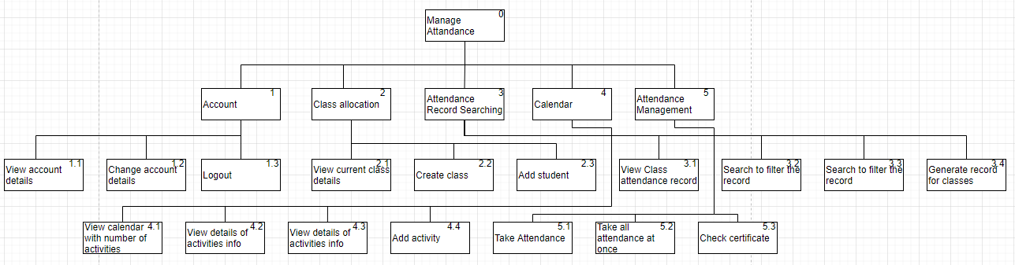

1. Web Design Concepts

Mental Model

Our target user are the novice of computers, we do not assume that they will not has a mental model of the application, so our design must be easy to use, user-friendly, to match this point.

Affordance

We designed the website to be “many functions in one interface”. In the below image, teacher can take attendance for students and check certificate

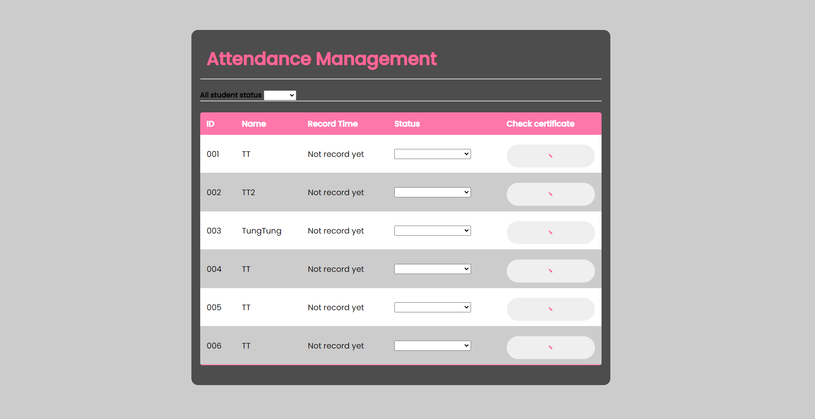

In the calendar, you can check activities by clicking the specific days in the calendar, add activities in the same page.

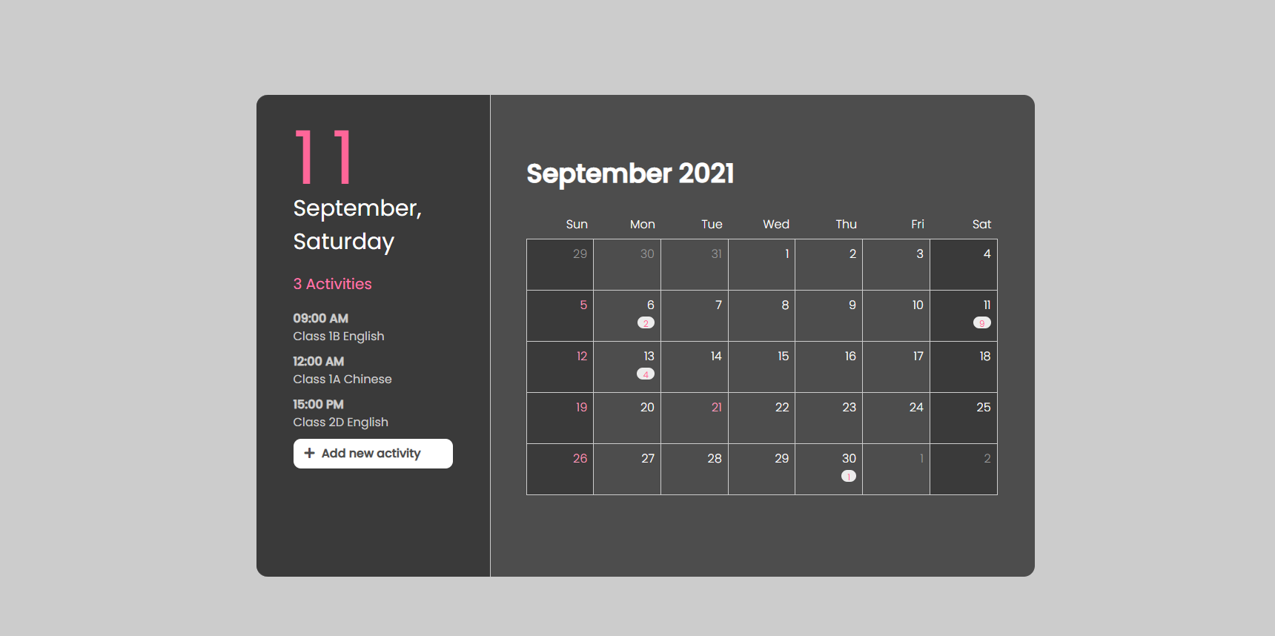

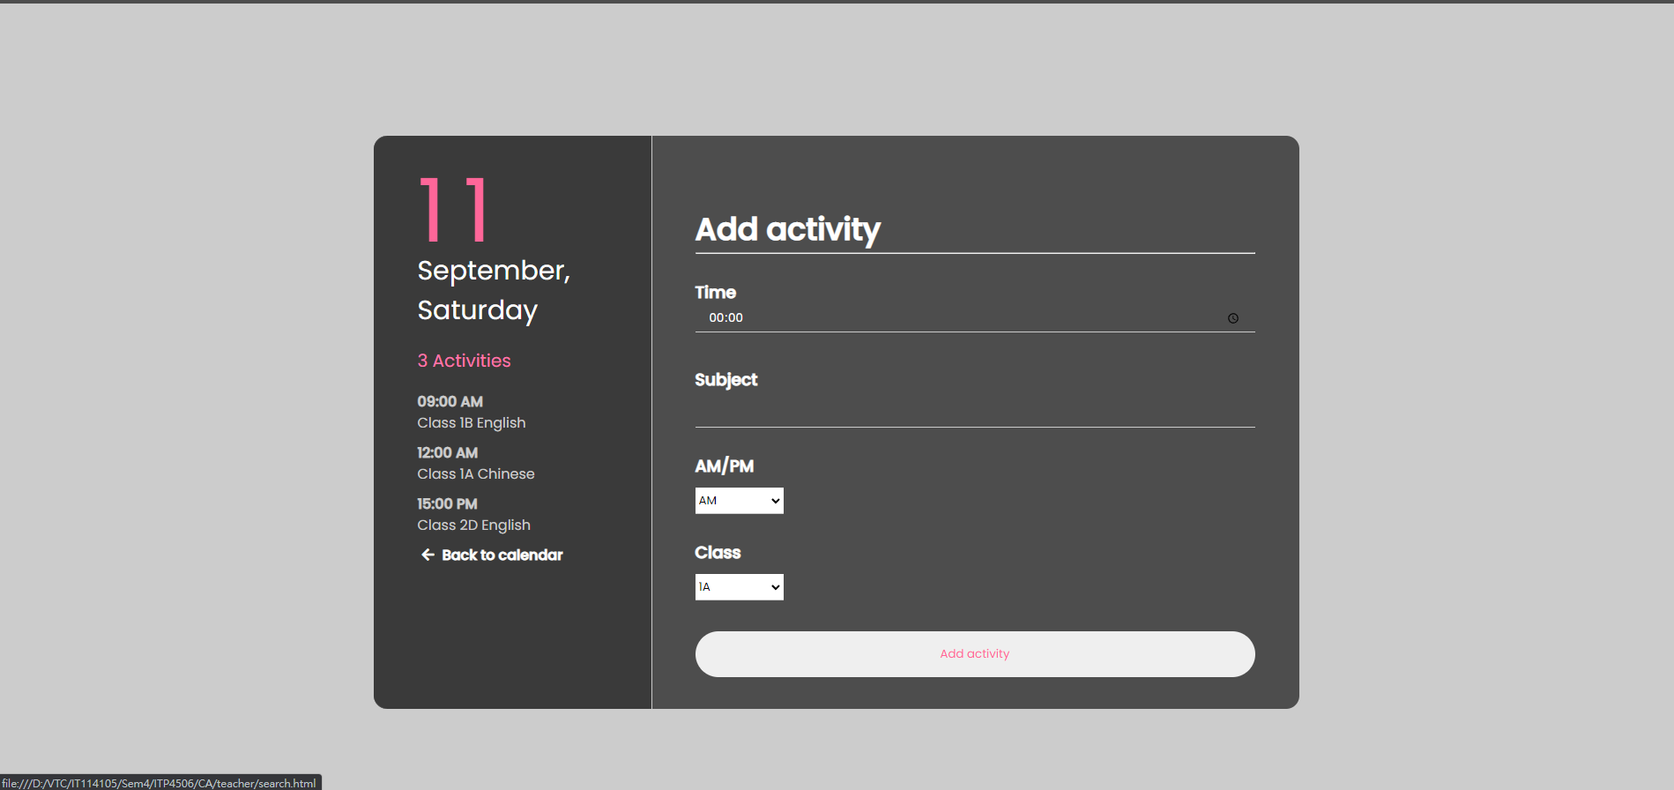

Content Organization

For the content organization, we decided to use a container to contain content in every single page, the benefit of this method is, the content will be more focus, if the content is too disperse, user will be distracted by the content.

We also used a method that will make the content will be more readable, for example, in the image below, you can only see a class allocation, but when you click the “Create class” or “Add student” button, it will pops up an additional field that let teacher enter the values to create class or add student

This method can let the teacher who only wanted to see the class allocation can only see the class allocation, but not both class allocation, create class, add student field, which is much more distracting to our method.

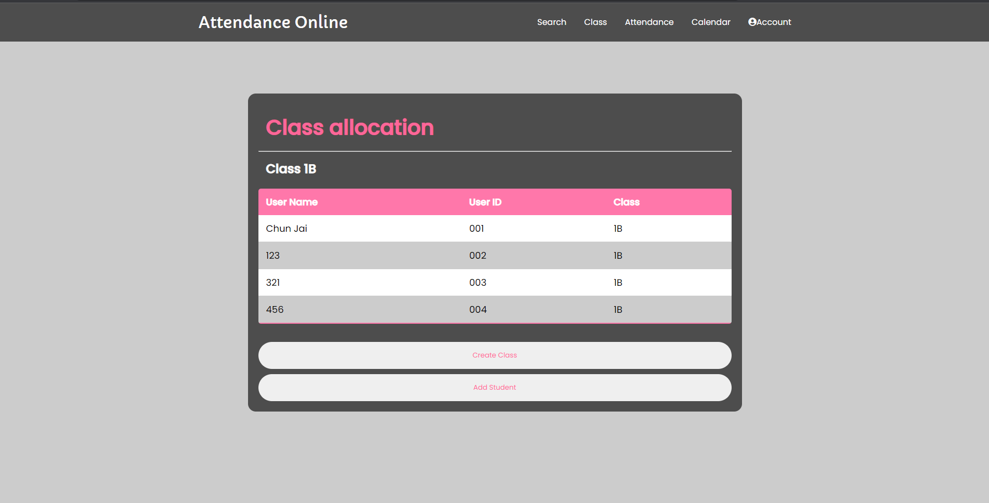

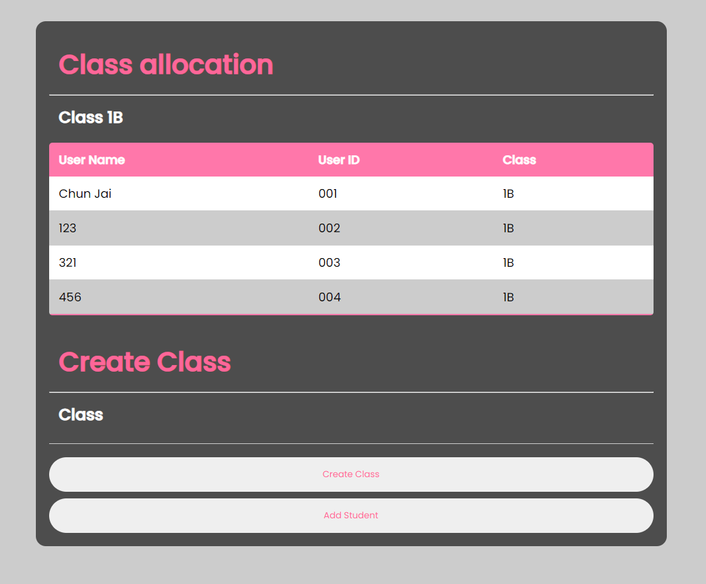

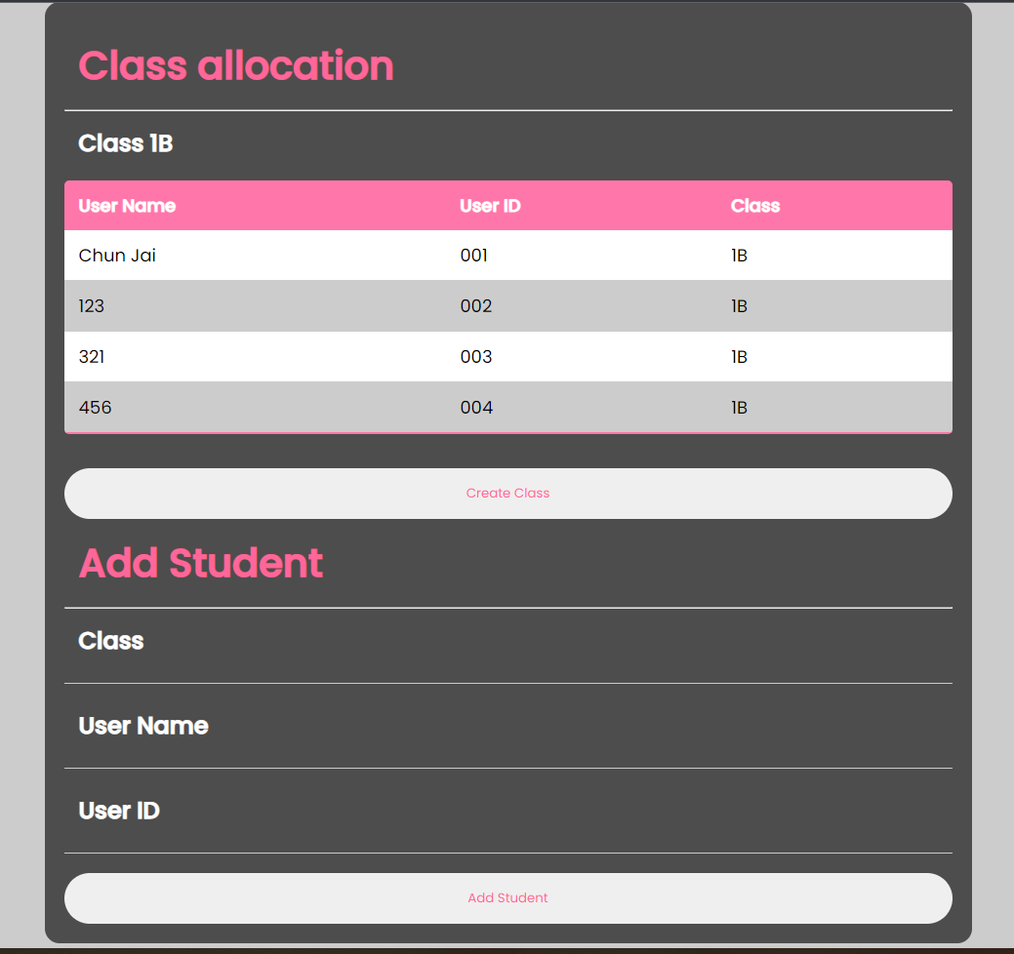

Visual Organization

In this part, we used many smooth visual affect for 80% of contents, this can help user to have a better visual experience when using this website.

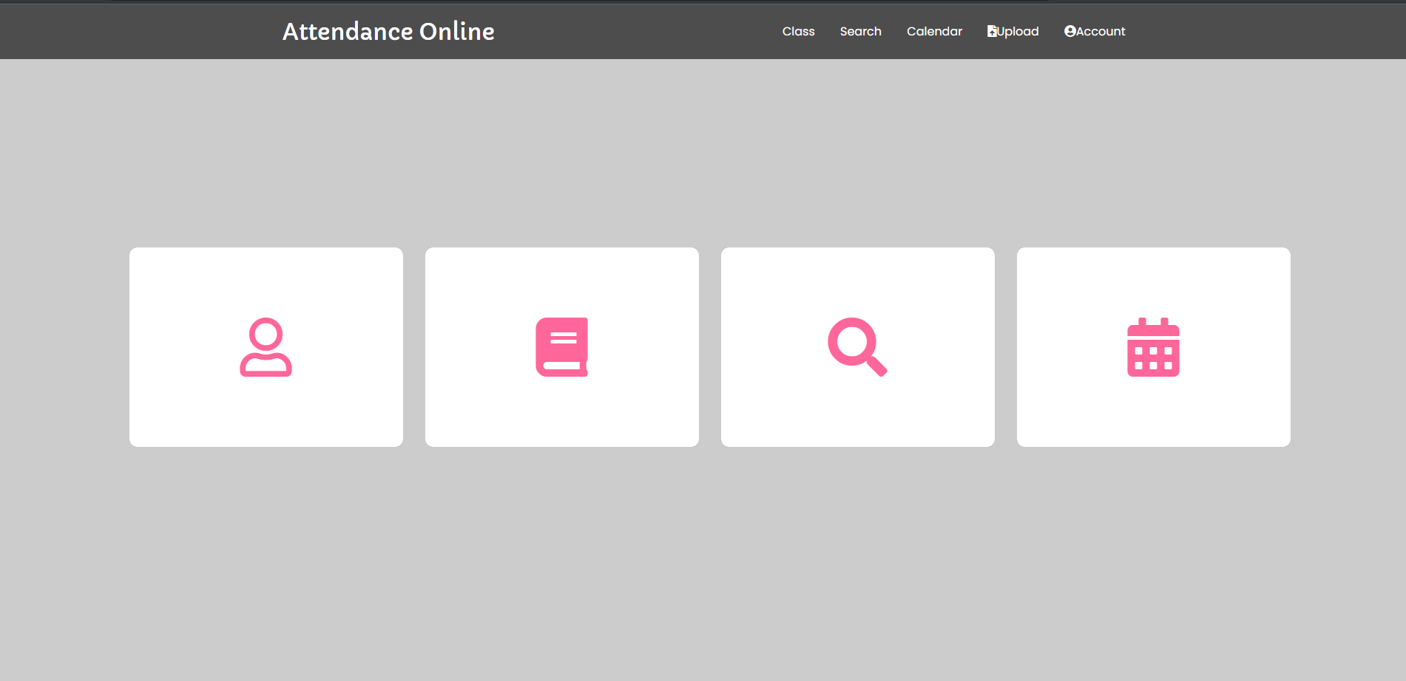

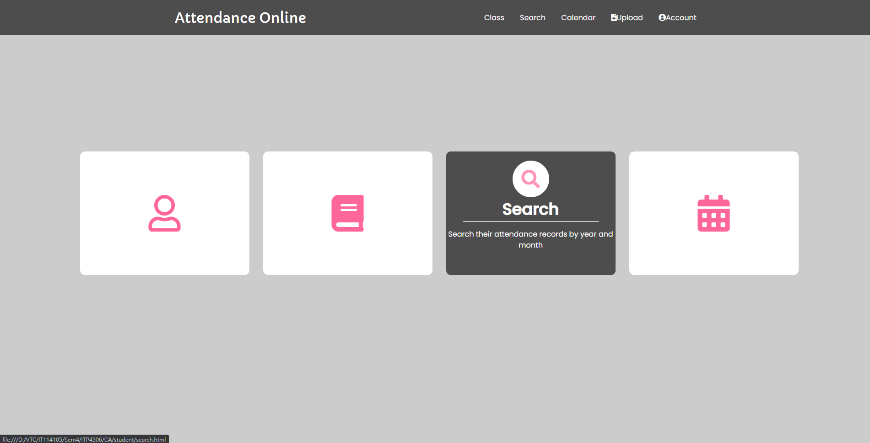

And for the color scheme, we only use maximum of 5 colors to be our color scheme, which can reduce the chance of getting visual fatigue when visiting our website.

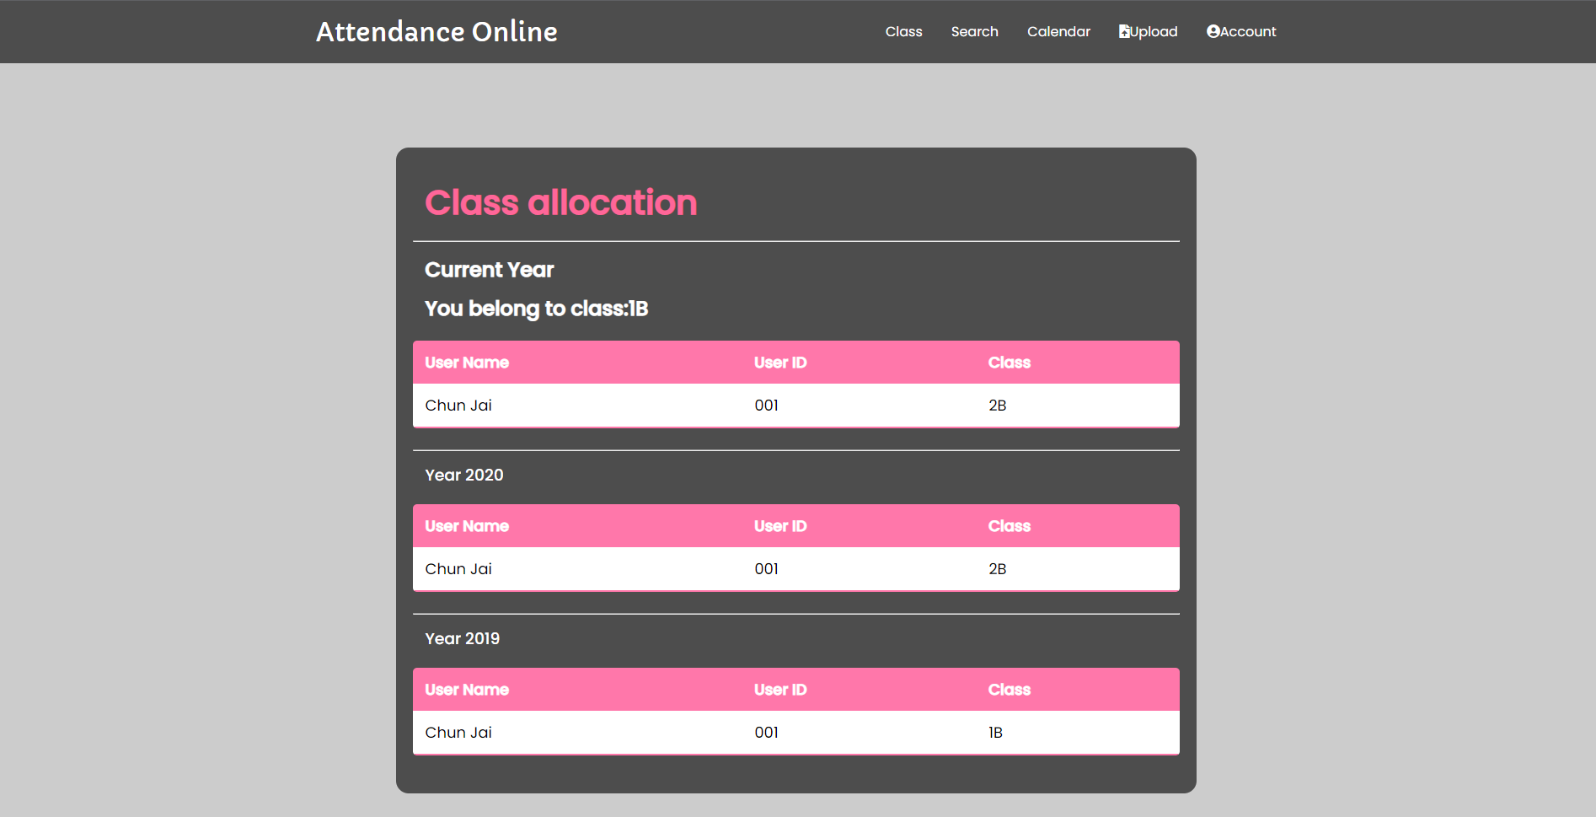

Navigation

In this part, we have a great navigation to guide the user to use different functions during visiting the website, for example, in the main page there are a few boxes which contain a logo, when you hover it, it will transform to a different form which contain description and the logo, user can understand what the boxes do very quickly.

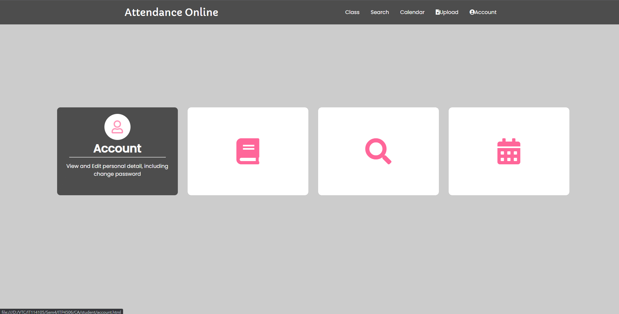

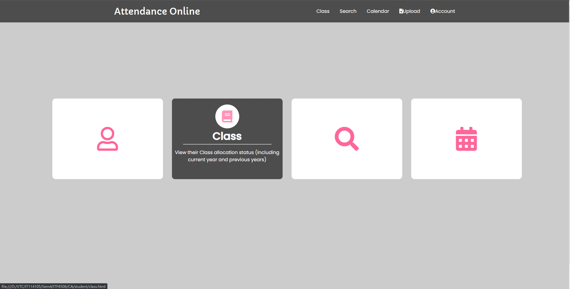

Also, we’re using a header which contains all the functions in the main page, and wherever page the user are, the can easily switch to another page by clicking the title in the header

